A

Minor Project-I Report

On

**“HOMEX REAL ESTATE”**

Submitted in partial fulfillment of

The requirements for the 5th Semester Sessional Examination of

BACHELOR OF TECHNOLOGY

IN

**COMPUTER SCIENCE & ENGINEERING**

By

**AMARNATH PANDA**

**SANCHITA SABAT**

**CHANDAN DANDIA**

**Registration No.**

**21UG010149**

**21UG010568**

**21UG010264**

**Under the able Supervision of**

**Dr. AVS PAWAN KUMAR**

**DEPARTMENT OF COMPUTER SCIENCE & ENGINEERI**

GIET UNIVERSITY, GUNUPUR

**2023 24**



**GIET UNIVERSITY,GUNUPUR**

***Dist. Rayagada, Odisha765022,* *Contact: +91 7735745535, 06857250170,172, Visit us:* www.giet.edu**

**Department of Computer Science & Engineering**



**CERTIFICATE**

**This is to certify that the project work entitled “HOMEX REAL ESTATE” is done by Name - AMARNATH PANDA , SANCHITA SABAT, CHANDAN DANDIA**

**Regd. No.- 21UG010149,21UG010568,21UG010264 in partial fulfillment of the requirements for the 5th Semester Sessional Examination of Bachelor of Technology in Computer Science and Engineering during the academic year 202324. This work is submitted to the department as a part of evaluation of 5th Semester Minor ProjectI.**

Project SupervIsor Class Teacher

Dr. AVS Pawan Kumar Miss. Pranita Mahapatro

Project Coordinator, 3rd Year HoD,CSE

Mr.Bhavani Sankar Panda Dr.Kakita Murali Gopaal

**ACKNOWLEDGEMENT**

We express our sincere gratitude to Prof. (Dr). AVS PAWAN KUMAR of Computer science and engineering for giving us an opportunity to accomplish the project. Without his/her active support and guidance, this project report has not been successfully completed.

We also thank Mr.Bhavani Sankar Panda, Project Coordinator, Dr. Kakita Murali Gopal, Head of the Department of Computer Science and Engineering, Prof. (Dr.) Sanjay Kumar Kuanar, Dy. Dean, Computational Science, SOET for their consistent support, guidance and help.

Amarnath panda (21UG010149)

Sanchita Sabat (21UG010568)

Chandan Dandia(21UG010264)

**ABSTRACT**

* **AIM:**

The project aims to redefine the traditional notions of urban development and create a

harmonious ecosystem where residents, businesses, and the environment thrive symbiotically Key objectives of the project include:

* **SUSTAINABLE INFRASTRUCTURE:**

The project emphasizes the integration of sustainable infrastructure practices, incorporating renewable energy sources, smart grid systems, and energy efficient design principles. By minimizing carbon emissions and optimizing resource consumption, the development aims to minimize its environmental impact and contribute to a greener future.

* **SMART TECHONOLOGY CONNECTIVITY:**

Leveraging cutting edge technologies, the project strives to create a smart and connected urban environment. Advanced data analytics, Internet of Things (IoT) devices, and intelligent transportation systems will enhance the quality of life for residents, streamline operational efficiency, and foster economic growth.

* **MIXED USE SPACE AND COMMUNITY ENGAGEMENT:**

1. The project recognizes the importance of fostering a sense of community and social interaction.
2. By integrating mixed use spaces such as parks, recreational areas, retail centers, and cultural hubs,
3. the development aims to create vibrant and inclusive neighborhoods. Community engagement
4. initiatives, such as participatory design processes and collaborative decision making platforms,
5. will empower residents to shape their surroundings and enhance social cohesion.

* **RESILENCY AND ADAPTABILITY:**

The project prioritizes resilience against natural disasters and climate change impacts. Incorporating resilient design elements, such as flood resistant structures, green infrastructure, and disaster response systems, the development aims to safeguard its inhabitants and minimize disruption in the face of future challenges.

* **ECONOMIC GROWTH AND INVESTMENT:**

The project envisions a robust economic ecosystem that attracts both local and international investors. By providing an attractive business environment, fostering entrepreneurship, and promoting innovation hubs, the development seeks to stimulate economic growth, generate employment opportunities, and position itself as a regional economic powerhouse.

**SOFTWARE USES:**

* **PHP**
* **MYSQL**
* **HTML**
* **CSS**
* **JAVASCRIPT**
* **PHP – Hypertext preprocessor:**

PHP, which stands for Hypertext Preprocessor, is a widely-used open-source scripting language that is especially suited for web development. It is embedded in HTML and executed on the server side, meaning that the PHP code is processed on the web server before the resulting HTML is sent to the client's browser. PHP is known for its simplicity, flexibility, and ease of integration with other web technologies.

* **Here are some key aspects of PHP:**
* **Server-Side Scripting**:

PHP is primarily designed for server-side scripting, allowing developers to create dynamic web pages and applications. It enables the execution of code on the server, generating content that is then sent to the client's browser.

* **Open Source**:

PHP is open source, meaning that its source code is freely available and can be modified and redistributed. This has contributed to a large and active community of developers who continually contribute to the language's growth and improvement.

* **Integration with HTML**:

One of PHP's strengths is its seamless integration with HTML. PHP code can be embedded directly into HTML, making it easy to mix dynamic content generation with static HTML content. This integration simplifies the development process and allows for the creation of dynamic, data-driven web pages.

* **Extensive Database Support**:

PHP has robust support for interacting with databases, making it a popular choice for developing database-driven web applications. It supports various database management systems, including MySQL, PostgreSQL, SQLite, and more. This capability is crucial for applications that require data storage and retrieval.

* **Platform Independence**:

PHP is platform-independent, meaning that it can run on various operating systems, including Windows, Linux, macOS, and others. This flexibility makes it accessible for a wide range of developers working in different environments.

* **Large Community and Documentation**:

The PHP community is extensive and active, providing ample resources for developers. The official PHP manual is comprehensive and well-maintained, offering documentation for functions, classes, and other language features.

* **Object-Oriented Programming (OOP) Support:**

While PHP initially started as a procedural language, it has evolved to include robust support for object-oriented programming. This allows developers to structure their code in a more modular and reusable manner.

* **Security Features**:

PHP has incorporated various security features to help developers build secure applications. However, like any programming language, the responsibility for secure coding practices lies with the developers themselves.

* **Frameworks:**

There are several popular PHP frameworks, such as Laravel, Symfony, and CodeIgniter, that provide pre-built modules and a structured architecture to streamline the development process. These frameworks help developers adhere to best practices and promote code maintainability.

Despite its strengths, PHP has faced criticism for certain historical design decisions and inconsistencies in its syntax. However, ongoing updates and improvements, as well as the active involvement of the PHP community, contribute to the language's resilience and relevance in the rapidly evolving landscape of web development.

* **MYSQL:**

MySQL is a popular open-source relational database management system (RDBMS) that plays a crucial role in managing and organizing structured data. Developed by Oracle Corporation, MySQL is widely used for web applications and is an integral part of the LAMP (Linux, Apache, MySQL, PHP/Perl/Python) and MERN (MongoDB, Express.js, React, Node.js) stacks.

* **Here are some key aspects of MYSQL:**
* **Open Source:**

MySQL is an open-source database system, which means its source code is freely available to the public. This openness fosters a collaborative environment, allowing developers to contribute to its improvement and adapt it to their specific needs.

* **Relational Database Management System (RDBMS):**

MySQL follows the relational database model, organizing data into tables with rows and columns. It supports SQL (Structured Query Language) for defining, querying, and manipulating data, adhering to the principles of relational databases.

* **Cross-Platform Compatibility:**

MySQL is cross-platform and can run on various operating systems, including Linux, Windows, macOS, and more. This flexibility makes it a versatile choice for developers working in different environments.

* **Scalability:**

MySQL is known for its scalability, supporting both small-scale applications and large, enterprise-level systems. It can handle high-traffic websites and applications with efficiency, and its scalability is one of the reasons for its widespread use in the web development industry.

* **Performance Optimization:**

MySQL provides various tools and features to optimize database performance. Indexing, caching mechanisms, and query optimization techniques are available to enhance the speed and efficiency of data retrieval and manipulation.

* **Data Security:**

MySQL includes robust security features to protect sensitive data. It supports user authentication and authorization, encryption, and access control mechanisms to ensure that only authorized users can interact with the database.

* **ACID Compliance:**

MySQL adheres to the ACID (Atomicity, Consistency, Isolation, Durability) properties, ensuring the reliability of transactions. This means that database transactions are processed reliably and consistently, even in the event of system failures.

* **Community and Support:**

MySQL has a large and active community of developers and users. This community support is valuable for troubleshooting issues, sharing knowledge, and staying updated on the latest developments. Additionally, MySQL offers commercial support options for enterprises that require more extensive assistance.

* **Storage Engines:**

MySQL supports multiple storage engines, each with its own characteristics and strengths. The Inno DB storage engine, for example, is widely used for its support of transactions and foreign keys, while My ISAM is known for its simplicity and speed.

* **Compatibility with Web Technologies:**

MySQL is frequently used in conjunction with web development technologies, especially in the context of dynamic websites and web applications. It seamlessly integrates with programming languages like PHP, Python, and others, making it a preferred choice for developers working on web-based projects.

* **Community Edition and Enterprise Edition:**

MySQL offers both a Community Edition, which is free and open source, and an Enterprise Edition with additional features and support services. The choice between the two depends on the specific requirements and resources of the organization.

MySQL's combination of performance, reliability, and flexibility has contributed to its widespread adoption across various industries. It continues to be a leading choice for developers and businesses seeking a robust and scalable database solution for their applications.

* **HTML - Hypertext Markup language**

It is the predominant markup language for web pages. It is the basic building blocks of web pages. A markup language is a set of mark tag and HTML uses markup tags to describe web pages. It provides a means to create structured documents by denoting structural semantics for text such as heading, paragraphs, lists etc., as well as for links, quotes, and other items. The W3C (world wide web consortium), maintainer of both HTML and CSS standards, encourages the use of CSS over explicit presentational markup. HTML, or Hyper Text Markup Language, is the standard markup language used to create and design web pages. It is an essential component of web development and is used in conjunction with other technologies like CSS (Cascading Style Sheets) and JavaScript to build interactive and visually appealing websites.

* **Here are key aspects of HTML:**
* **Markup Language:**

HTML is a markup language, not a programming language. It is used to structure content on the web by adding elements and tags to text, images, links, forms, and other types of media. These elements define the structure and semantics of a document, helping browsers interpret and display content correctly.

* **Document Structure:**

HTML documents are structured as a hierarchy of elements, with a root <html> element containing <head> and <body> sections. The head typically includes metadata such as the document's title and links to external resources, while the body contains the main content of the page.

* **Elements and Tags:**

HTML consists of a set of predefined elements, each represented by tags enclosed in angle brackets. For example, the <p> tag is used to define paragraphs, <h1> to <h6> for headings, <a> for links, and <Img> for images. Attributes can be added to elements to provide additional information or modify their behavior.

* **Semantic Markup:**

HTML5, the latest version of HTML, introduced a focus on semantic markup, which involves using tags that convey the meaning of content rather than just its appearance. Semantic tags like <article>, <section>, <nav>, and <footer> provide clarity to both developers and browsers about the purpose of different parts of the document.

* **Hyperlinks:**

HTML enables the creation of hyperlinks using the <a> (anchor) element. Links can point to other web pages, resources, or locations within the same page. Attributes such as ‘href’ define the destination of the link.

* **Forms:**

HTML includes a comprehensive set of form elements, such as <input>, <text-area>, and <select>, allowing users to input data. Forms are essential for user interactions, like submitting data, conducting searches, or logging in.

* **Multimedia Integration:**

HTML supports the embedding of multimedia content through elements like <audio> and <video>. This enables the inclusion of audio and video files directly within web pages without relying on external plugins.

* **Cross-Browser Compatibility:**

HTML is designed to be cross-browser compatible, meaning that web pages written in HTML should render consistently across different web browsers. However, variations in browser implementations can sometimes lead to minor differences in appearance and behavior.

* **Responsive Web Design:**

HTML plays a crucial role in creating responsive web designs that adapt to various screen sizes and devices. The use of flexible layouts, media queries, and responsive images allows developers to build websites that work seamlessly on desktops, tablets, and smartphones.

* **Evolution and Standards:**

HTML has gone through several versions of evolution, with HTML5 being the latest standard as of my knowledge cutoff in January 2022. New features and improvements, such as native support for multimedia and enhanced form elements, have been introduced in each version to keep up with the evolving needs of web development.

* **Accessibility:**

HTML supports web accessibility standards, allowing developers to create websites that are inclusive and accessible to users with disabilities. Semantic HTML, proper document structure, and the use of ARIA (Accessible Rich Internet Applications) attributes contribute to better accessibility.

In summary, HTML serves as the backbone of web development, providing the structure and foundation for creating content-rich and interactive websites. It is a fundamental skill for web developers and is often the starting point for anyone learning about web development.

* **CSS- Cascading style sheet:**

A style sheet, known as CSS (Cascading style sheet), language used to describe the presentation semantics of document written in a markup language. One of its most common applications is to style web pages written in HTML and XHTML, but the language can be applied to any kind of XML document, including SVG (Scalable vector graphics) and XUL (XML User interface language). CSS, or Cascading Style Sheets, is a crucial technology in web development used to describe the presentation and layout of HTML documents. It enables developers to control the appearance of web pages by defining styles for elements, such as fonts, colors, spacing, and positioning. CSS works hand-in-hand with HTML to create visually appealing and responsive web designs.

* **Here are key aspects of CSS:**
* **Separation of Concerns:**

One of the fundamental principles of web development is the separation of concerns, and CSS excels in this regard. It allows developers to separate the structure (HTML) from the presentation (CSS) and behavior (JavaScript) of a web page. This separation enhances code maintainability, readability, and reusability.

* **Selectors and Declarations:**

CSS uses selectors to target HTML elements and declarations to define how those elements should be styled. For example, to style all paragraphs in a document, you might use the selector p and declare properties like color, font-size, and margin.

* **Box Model:**

The CSS box model is a foundational concept that defines how elements are structured on a web page. Each element is considered a box with properties like content, padding, border, and margin. Understanding the box model is essential for controlling layout and spacing.

* **Layout and Positioning:**

CSS provides various layout and positioning techniques to control the placement of elements on a page. Techniques like Flexbox and Grid layout have been introduced to simplify the creation of complex and responsive layouts.

* **Responsive Design:**

With the increasing diversity of devices and screen sizes, responsive design has become crucial. CSS supports media queries, allowing developers to apply different styles based on the characteristics of the device, such as screen width, height, or orientation.

* **Transitions and Animations:**

CSS supports transitions and animations, enabling developers to create smooth and visually appealing effects. This can include hover effects, fade-ins, or more complex animations to enhance user experience.

* **Vendor Prefixes:**

To handle browser-specific implementations, CSS often requires the use of vendor prefixes. These prefixes are used for experimental or non-standard CSS properties and ensure compatibility with various browsers.

* **CSS Preprocessors:**

CSS preprocessors like Sass and Less extend the functionality of CSS by introducing features like variables, nesting, and functions. These preprocessors help developers write more maintainable and efficient stylesheets.

* **Flexibility:**

CSS is a flexible language that allows developers to adapt to different design requirements. It supports a wide range of styling options, from simple text formatting to complex layout structures.

* **Browser Compatibility:**

While CSS aims for consistency across browsers, differences in browser implementations can sometimes lead to compatibility issues. Developers often need to test and adjust styles to ensure a consistent user experience across different browsers.

In summary, CSS is a powerful tool for web developers, enabling them to control the visual presentation of web pages. Its capabilities extend beyond simple styling, encompassing layout, responsiveness, and interactive features. As the web development landscape continues to evolve, CSS remains a critical skill for creating modern and engaging user interfaces

* **JAVASCRIPT:**

JavaScript is a versatile and widely-used programming language that plays a central role in web development. Initially designed to add interactivity to web pages, JavaScript has evolved into a full-fledged programming language capable of both client-side and server-side development.

* **Here are key aspects of JavaScript:**
* **Client-Side Scripting:**

JavaScript is primarily known for its role in client-side scripting. When embedded in HTML documents, it runs in the user's web browser and enables dynamic and interactive content. This includes actions like form validation, DOM manipulation (Document Object Model), and handling events like clicks and keypresses.

* **ECMAScript Standard:**

JavaScript is based on the ECMAScript standard, which defines the scripting language's core features and syntax. ECMAScript ensures a level of consistency across different implementations of JavaScript in various web browsers.

* **Variables and Data Types:**

JavaScript supports dynamic typing, allowing developers to use variables without explicitly declaring their data type. Common data types include strings, numbers, booleans, objects, and arrays.

* **Functions:**

Functions are a fundamental concept in JavaScript. They allow developers to encapsulate reusable pieces of code. Functions can be declared and called with or without parameters.

* **Frameworks and Libraries:**

JavaScript has a rich ecosystem of frameworks and libraries that simplify and accelerate development. Popular front-end frameworks include React, Angular, and Vue.js, while Node.js is a popular runtime for server-side JavaScript.

* **Security Considerations:**

As with any programming language, security is a crucial consideration in JavaScript development. Cross-Site Scripting (XSS) and Cross-Site Request Forgery (CSRF) are common security challenges, and developers must implement best practices to mitigate these risks.

**Chapter:1**

**INTRODUCTION**

**INTRODUCTON: REAL ESTATE PORTAL**

Welcome to our innovative and user-friendly Real Estate Portal, a dynamic web application designed to simplify the process of buying, selling, and renting properties. Developed with a modern and responsive approach, this platform seamlessly integrates PHP, HTML, JAVASCRIPT, CSS, and MYSQL to provide a feature rich and visually appealing experience for users in the real estate market.

**1.1 KEY FEATURES:**

**1.1.1 Property Listings:**

Browse through an extensive database of residential and commercial properties. Our user-friendly interface allows users to filter and search for properties based on various criteria such as location, price range, and property type.

**1.1.2 Property Details:**

Gain in depth insights into each property with detailed descriptions, high quality images, and key features. Our platform ensures that users have access to comprehensive information to make informed decisions.

**1.1.3 User Authentication:**

A secure user authentication system ensures that both buyers and sellers can create accounts, manage their profiles, and track their property transactions with confidence.

**1.1.4 Responsive Design:**

The responsive design of our web application ensures a seamless experience across various devices, including desktops, tablets, and smartphones. Users can access the platform anytime, anywhere.

**1.1.5 Interactive Maps:**

Explore properties visually through integrated maps that provide a clear understanding of the property's location and its proximity to essential amenities.

**1.1.6 Contact and Inquiry Forms:**

Connect effortlessly with property owners or real estate agents through integrated contact and inquiry forms. This feature facilitates smooth communication and collaboration between buyers and sellers.

**1.1.7 Dynamic Admin Panel:**

An intuitive administrative panel allows real estate professionals to manage property listings, user accounts, and monitor overall platform activity. This ensures efficient management and updates.

**1.2 TECHNOLOGY PACK:**

**1.2.1** **Backend**:

PHP is employed for server-side scripting to handle database interactions, user authentication

and overall application logic.

**1.2.2** **Frontend**:

HTML, CSS, and JavaScript contribute to the sleek and interactive user interface, providing a

seamless browsing experience.

**1.2.3 Database:**

MySQL is utilized to store and retrieve property listings, user profiles, and other essential data

It ensures efficient data management and retrieval for a seamless user experience.

Our Real Estate Portal is not just a platform; it's a comprehensive solution designed to empower users in the real estate industry. Whether you are a property seeker, seller, or agent, our web application is tailored to meet your needs and elevate your real estate experience. Explore the possibilities and find your perfect property with ease on our Real Estate Portal

**1.3 PURPOSE:**

The purpose of the Real Estate Portal described in the introduction is to provide a comprehensive and user-friendly online platform for individuals involved in the real estate market. This portal serves various purposes for different user groups:

**1.3.1 Property Seekers:**

* **Property Exploration:** Users can easily browse and explore a diverse range of residential and commercial properties.
* **Detailed Information:** Property seekers can access detailed information about each listing

that Includes descriptions, images, and key features.

* **Search and Filter**: The platform allows users to search for properties based on specific

criteria such as location, price range, and property type.

* **Contact and Inquiry**: Interested users can connect with property owners or agents through

integrated contact and inquiry forms.

**1.3.2 Property Sellers:**

* **Listing Management:** Property sellers, including individuals and real estate agents, can efficiently manage and update property listings through a dynamic admin panel.
* **User Authentication:** Secure user authentication ensures that property sellers have control over their accounts and listings.
* **Communication:** Sellers can receive inquiries and messages from potential buyers through the platform's communication features.

**1.3.3 Real Estate Professionals:**

* **Admin Panel:** Real estate professionals can use the dynamic admin panel to monitor overall platform activity, manage user accounts, and ensure the accuracy of property listings.
* **Efficient Management:** The portal streamlines the management of property related data, ensuring efficient data retrieval and updates.

**1.3.4 General Users:**

* **Responsive Design:** The responsive design of the portal ensures a seamless user experience across various devices, making it accessible to a wide audience.
* **Map Integration:** Interactive maps provide a visual representation of property locations and their proximity to amenities.

In summary, the purpose of the Real Estate Portal is to create a centralized and accessible platform that facilitates property transactions, enhances communication between buyers and sellers, and provides a user-friendly experience for all participants in the real estate market. The integration of PHP, HTML, JavaScript, CSS, and MySQL contributes to the development of a robust and feature rich solution that meets the diverse needs of its users.

**1.4 PROJECT SCOPE:**

The scope of a real estate web project developed using PHP, HTML, JavaScript, CSS, and MYSQL can be broad and depends on the specific requirements and goals of the project stakeholders.

Below are various aspects of the project scope that might be considered:

**1.4.1 User Roles and Features:**

* Identify different user roles, such as property seekers, sellers, and administrators.
* Define features for each user role, such as property listing management, user authentication

search functionalities, and communication tools.

**1.4.2 Property Management:**

* Specify the types of properties supported (residential, commercial, etc.).
* Define the data fields for property listings (e.g., location, price, description, images) Include features for property status (available, sold, rented) and property details.

**1.4.3 User Authentication and Profiles:**

* Implement secure user authentication for account creation and login.
* Define user profiles for both property seekers and sellers, allowing them to manage their

information and activities.

**1.4.4. Search and Filtering:**

* Specify criteria for property search and filtering (location, price range, property type).
* Implement an intuitive and efficient search and filtering mechanism.

**1.4.5. Communication and Inquiry:**

* Include features for users to contact property sellers or agents.
* Implement inquiry forms and messaging systems to facilitate communication.

**1.4.6. Responsive Design:**

* Ensure a responsive design that provides a seamless user experience across various devices

and screen sizes.

**1.4.7. Admin Panel:**

* Create an administrative panel for real estate professionals to manage property listings, user accounts, and overall platform activity.
* Implement tools for monitoring and maintaining the platform.

**1.4.8. Interactive Maps:**

* Integrate maps to provide users with a visual representation of property locations.

**1.4.9. Technology Stack:**

* Clearly define the technologies used in the project (PHP, HTML, JavaScript, CSS, MySQL).
* Consider scalability and potential future integrations.

**1.4.10. Testing and Quality Assurance:**

* Define the scope of testing, including unit testing, integration testing, and user acceptance testing.
* Ensure the project meets quality standards and is free of bugs.

**1.4.11. Documentation:**

* Include documentation for developers, administrators, and end users.
* Document the database schema, code structure, and any important implementation details.

**1.4.12. Security:**

* Implement security measures to protect user data and prevent unauthorized access.
* Include features such as secure password storage, data encryption, and secure communication.

**1.4.13. Deployment and Maintenance:**

* Define the deployment process for moving the project from development to production.
* Outline plans for ongoing maintenance, updates, and support.

It's essential to collaboratively define the project scope with stakeholders, ensuring a clear understanding of expectations and deliverables. Regular communication and feedback during the development process help in managing scope changes and ensuring that the final product aligns with the stakeholders' needs.

**1.5 PROJECT FEATURES:**

Certainly! Below are some key features that you might consider incorporating into your real estate web project.

The features are categorized based on the different aspects of the platform:

**1.5.1 User Authentication and Profiles:**

* **User Registration and Login:**

Allow users to create accounts and log in securely.

* **User Profiles:**

Enable users to create and manage profiles with personal information.

**1.5.2 Property Listings:**

* **Property Search and Filtering:**

Implement a robust search functionality with filters based on location, price, property type,

etc.

* **Detailed Property Listings:**

Provide comprehensive details for each property, including descriptions, images, and key

Features.

**1.5.3 Communication and Interaction:**

* **Inquiry Forms:**

Include forms that users can use to inquire about specific properties.

* **Messaging System:**

Facilitate communication between property seekers and sellers through an integrated

messaging system.

**1.5.4 Property management:**

* **Property Listing Management:**

Allow property sellers or agents to manage their property listings, including adding, editing

and removing listings.

* **Property Status:**

Implement features to indicate the status of a property (available, sold, rented).

**1.5.5 Interactive Maps:**

Integrate maps to provide a visual representation of property locations.

**1.5.6 User Reviews and Ratings:**

Allow users to leave reviews and ratings for properties and agents.

**1.5.7 Admin Dashboard:**

Create an intuitive dashboard for administrators to monitor and manage the platform.

**1.5.8 User and Listing Management:**

Provide tools for administrators to manage user accounts, listings, and other content.

**1.5.9 Responsive User Interface:**

Ensure that the platform is accessible and provides a seamless experience across various

devices.

**Chapter:2**

**WORK DONE IN REALTED AREAS**

The real estate industry is vast, with various jobs available to those interested in assisting with the purchase, management or sale of properties. You can work in the residential, commercial or retail real estate industry. Understanding the different occupations available in real estate can help you determine which aspect of the industry is right for your skills and preferences.

The real estate industry manages the renting, purchasing and selling of properties. This can include undeveloped land and developed residential and commercial buildings. There are many jobs available in real estate for knowledgeable individuals to guide the process of obtaining mortgage loans, selling real estate, managing rental properties, developing new properties and listing real estate for sale.

In the realm of real estate web applications, a variety of works and features are implemented to enhance user experience, streamline processes, and provide valuable information.

Here are some common functionalities and works found in real estate web applications:

**2.1 Property Listings and Search:**

**2.1.1 Dynamic Property Listings:**

* Real estate websites typically feature a dynamic and extensive database of property listings. These listings often include details such as property type, location, price, amenities, and photos.

**2.1.2 Advanced Search Filters:**

* Users can often refine property searches based on specific criteria such as location, price range, number of bedrooms, and more.
* Advanced filters help users narrow down their options and find properties that match their preferences.

**2.2 Interactive Maps:**

**2.2.1 Geolocation and Mapping Integration:**

* Real estate web applications often integrate interactive maps, allowing users to visualize property locations.
* Mapping features are particularly useful for users who want to explore neighborhoods and nearby amenities.

**2.3 User Accounts and Profiles:**

**2.3.1 User Registration and Login:**

* Users can create accounts to save favorite listings, receive notifications, and track their search history. Account features enhance the user experience by providing personalized services.

**2.3.2 Profile Management:**

* Users can manage their profiles, update preferences, and track their activity within the platform.

**2.4 Property Details and Multimedia:**

**2.4.1 Comprehensive Property Information:**

* Each property listing typically includes detailed information such as property size, layout, features, and contact details for the listing agent.

**2.4.2 High-Quality Media:**

* Images, virtual tours, and videos are often included to provide a comprehensive view of the property.

**2.5 Mortgage Calculators:**

**2.5.1 Financial Tools:**

* Real estate web applications may offer mortgage calculators to help users estimate monthly payments based on property price, down payment, interest rates, and loan terms.

**2.6 Real-Time Notifications:**

**2.6.1 Alerts and Updates:**

* Users can set up alerts for new listings that match their criteria. Real-time notifications ensure that users are promptly informed about relevant properties.

**2.7 Agent and Broker Profiles:**

**2.7.1 Agent Directories:**

* Users can browse profiles of real estate agents and brokers, including their experience, specialties, and client reviews.

**2.7.2 Contact and Communication:**

* The platform facilitates communication between users and agents, allowing users to inquire about properties or schedule viewings.

**2.8 Mobile Responsiveness:**

**2.8.1 Cross-Platform Compatibility:**

* Real estate web applications are often designed to be responsive, ensuring a seamless experience across various devices, including desktops, tablets, and smartphones.

**2.9 Transaction Management:**

* + 1. **Document Handling:**
* Some platforms facilitate the management of transaction-related documents, making it easier for buyers, sellers, and agents to collaborate throughout the transaction process.
  + 1. **Digital Signatures:**
* Integration with digital signature platforms streamlines the signing of contracts and other essential documents.

**2.10 Community and Neighborhood Information:**

**2.10.1 Local Amenities:**

* Real estate websites may provide information about nearby schools, parks, shopping centers, and other amenities to help users assess the neighborhood.

**2.11 Market Trends and Insights:**

**2.11.1 Data Analytics:**

* Some platforms offer market trends, statistics, and insights to help users make informed decisions about buying or selling properties.

**2.12 Reviews and Ratings:**

**2.12.1 User Feedback:**

* Users can leave reviews and ratings for properties or agents, contributing to a transparent and trustworthy ecosystem.

The development of real estate web applications involves a combination of web development, data management, user experience design, and integration with external services. As technology evolves, real estate platforms continue to explore innovations such as augmented reality (AR), artificial intelligence (AI)-driven recommendations, and blockchain for secure and transparent transactions.

* **USER INTERFACE:**

The web site will include user interfaces both for the potential clients and the owner\administrator for the site. There will be proper validation on each user interface page providing appropriate messages if any information is incorrectly entered. Each page of the web site will include a header and footer page through out of the web site. The header will include the owner\administrator’s logo, navigation bar, and control panel. The control panel will provide the user the opportunity to enter their existing password and user name for logging into their profile. The footer will contain copyright information.

* **HOMEPAGE:**

The home page will display control panel, other various links such as buy property, sell property, about us, contact us, login, logout, provided to user. There will be another control panel link allowing the owner/administrator to login to their control panel.

* **BUY SEARCH LISTING:**

The search listing page will allow the user to perform a detailed search of any available properties within the web site. Some of the search features will include bathroom, bedrooms, price range, and location, among many others.

* **CONTROL PANEL LOGIN:**

The administrator login page will allow the admin/owner to login into the administrative area for creating, modifying, and deleting listings. The owner/administrator must provide a valid username and password.

* **REGISTER:**

On the full featured version of this web site, the registration page will allow more owner/administrator to create an account on the site. This page will collect information such as first name, last name, company name, description, location, address, username, password, etc. there are some required fields such as user name, password and other. Once the realtor completes the registration and their registration is confirmed, the owner/administrator is logged in their “control panel” page is down.

* **CONTACT US:**

The contact us will provide the user the means to send an email to the web site’s administrator. The user will be required to enter first name, last name, address, phone number, email and message.

* **OWNER’S PROFILE:**

The owner’s profile page will display the owner/administrator’s name, description, address, and mobile number.

* **ADMINISTRATOR (REALTOR):**

The administrator page will display the entire tasks associated with action the realtor can perform such as create role, adding, editing, or deleting property details, changing their contact information (name, company, phone, etc).

* **ADD LISTING:**

The add listing page will allow the owner/administrator to add images, property types, description and various other features such as bathrooms, bedrooms, location, address, price, etc. after the required fields and optional fields are entered, the owner/administrator will hit the add property button to add that listing. Any required fields not filled will required information before proceeding.

* **LISTINGS DISPLAY:**

The listing display page will allow the potential client the option to view all the detail

information that listing has available. The user can view the text, any photos of the listing.

**Chapter:3**

**SYSTEM ANALYSIS**

**USER REQUIREMENTS (SRS):**

“A condition needed by the user to solve a problem and achieve a goal.”

1. The software requirement specification is a document that describe completely what the propose software what should do without describe how software will do it.
2. The register function allows the user to register with the real estate web site so they can buy list properties.

**Steps-**

1. The user navigates to the real estate web site.
2. The user clicks the “Register” on the top of the home page.
3. The users enter the required information such as their name, last name, password, password confirmation, email address, email address confirmation, phone number, address, city, state, zip code, among other.
4. The user clicks the register” button.

**MINIMUM SOFTWARE REQUIREMENT:**

**Front End:**

* HTML
* CSS

**Back end:**

* JAVASCRIPT
* MYSQL
* PHP

**MINIMUM HARDWARE REQUIREMENT:**

* Intel Processor or AMD processor with 1 gigahertz (GHz).
* 4 GB RAM(RANDOM ACCESS MEMORY) .
* 20 GB HDD(HARD DISK) .

**Chapter 4**

**SYSTEM DESIGN AND SPECIFICATION**

**4.1 INTRODUCTION**

Design is the first step in the development phase for an engineered product or system. Design is the place where quality is fostered in software development. Design is the only way that we can accurately translate a user-requirement into a finished software product or system. Software design serves as the foundation for all software engineers and software maintenance steps that follow. Without design we risk building an unstable design-one that will fail when small changes are made.

There are three actors in this project.

* USER (CUSTOMER)
* SUPERVISER
* ADMINITRATOR (ADMIN)

**USER:**

In this project the user is main part of this site to use the software for buy and sell the property. User check the software to the property details and get information of the property through the web site.

**SUPERVISOR:**

* The supervisor in this site to manage the transection of the property details for the customer.
* The supervisor manages the details delete the old property details and view new property and manage transection.

**ADMINISTRATOR:**

The administrator is the main actor of this site. He is the owner of this site. All transection manages through the admin in the web site. The admin manages all transection in the software to require new.

* 1. **SYSTEM DESIGN**

|  |
| --- |
| manage  Administrator  Visitor  Properties  advertises  Seller or renter  manage  manage |

**4.3 STRUCTURE CHART:**

**4.4 DATA FLOW DIAGRAM (DFD):**

The dataflow diagrams (DFDs) reveal relationships among and between the various components in a program or system. DFDs are an important technique for modeling a system’s high-level detail by showing how input data is transformed to output results through a sequence of functional transformations.

DFDs consist of four major components:

* ENTITIES
* PROCESSES
* DATA STORES
* DATA FLOWS

The symbols used to depict how these components interact in a system are simple and easy to understand. How ever these are several DFD models to work form, each having its own symbology. DFD syntax does remain constant by using simple verb and noun constructs. Such a syntactical relationship of DFDs makes them ideal for object - oriented analysis and parsing functional specification into precise DFDs for the system analyst. When it comes to conveying how information data flows through systems (and how that data is transformed in the process), data flow diagrams DFDs are the method of choice over technical descriptions for three principal reasons.

DFDs are easier to understand by technical and nontechnical audiences.

DFDs can provide a high-level system over view, complete with boundaries and connections to other systems.

FOUR SIMPLE NOTATIONS ARE USED TO COMPLETE A DFD.

* DATA FLOW
* PROCESS
* EXTERNAL ENTITY
* DATA STORE
* **DATA - FLOW:**
* The previous three symbols may be interconnected with data flows. These represent the flow of data to or from a process. The symbol is an arrow and next to it a brief description of the data that is represented. There are some interconnections, though, that o This would mean that an external entity could read or write to the data stores having direct access. Again in practice this must involve a process. Also, it is unusual to show interconnections between external entities. We are not normally concerned with information exchanges between two external entities as they are outside our system and therefore of less interest to us.
* The data flow is used to describe the movement of information from one part of the system to another part. Flows represent data in motion. It is a pipe line through which information flow of Data flow is represented by an arrow.

Data flow

* **PROCESS:**
* Processes are actions that are carried out with the data that flows around the system. A process accepts input data needed for the process to be carried out and produces data that it passes on to another part of the DFD. The processes that are identified on a design DFD will be provided in the final artefact. They may be provided for using special screens for input and output or by the provision of specific buttons or menu items. Each identifiable process must have a well-chosen process name that describes what the process will do with the information it uses and the output it will produce. Process names must be well chosen to give a precise meaning to the action to be taken. It is good practice to always start with a strong verb and to follow with not more than four Try to avoid using the verb ‘process’, otherwise it is easy to use this for every process. We already know from the symbol it is a process so this does not help us to understand what kind of a process we are looking at.
* A circle or bubble represents a process that transforms incoming data to outgoing data. Process shows a part of the system that transform inputs to outputs.
* **EXTERNAL ENTITY:**
* External entities are those things that are identified as needing to interact with the system under consideration. The external entities either input information to the system, output information from the system or both. Typically they may represent job titles or other systems that interact with the system to be built. Some examples are given below in Figure 1. Notice that the SSADM symbol is an ellipse. If the same external entity is shown more than once on a diagram (for clarity) a diagonal line indicates this.
* A square defines a source or destination of system Information from the system but is not a part of the system. External entities represent any entity that supplies or receive.

**EXTERNAL ENTITY**

* **DATA STORE:**
* Data stores are places where data may be stored. This information may be stored either temporarily or permanently by the user. In any system you will probably need to make some assumptions about which relevant data stores to include. How many data stores you place on a DFD somewhat depends on the case study and how far you go in being specific about the information stored in them. It is important to remember that unless we store information coming into our system it will be lost.
* The data store represents a logical file. A logical file can represent either a data store symbol which can represent either a data structure or a physical file on disk.

Data store

**0-LEVEL DFD:**

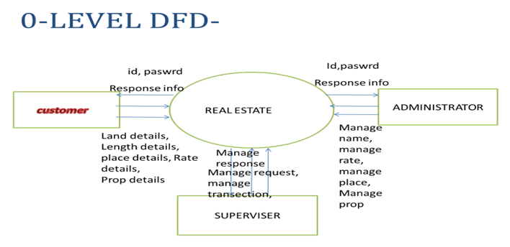

**LEVEL-1 DFD:**

* Level 1 DFD’s aim to give an overview of the full system. They look at the system in more detail. Major processes are broken down into sub-processes. Level 1 DFD’s also identifies data stores that are used by the major processes.
* When constructing a Level 1 DFD, we must start by examining the Context Level DFD. We must break up the single process into its sub-processes. We must then pick out the data stores from the text we are given and include them in our DFD. Like the Context Level DFD’s, all entities, data stores and processes must be labelled. We must also state any assumptions made from the text.

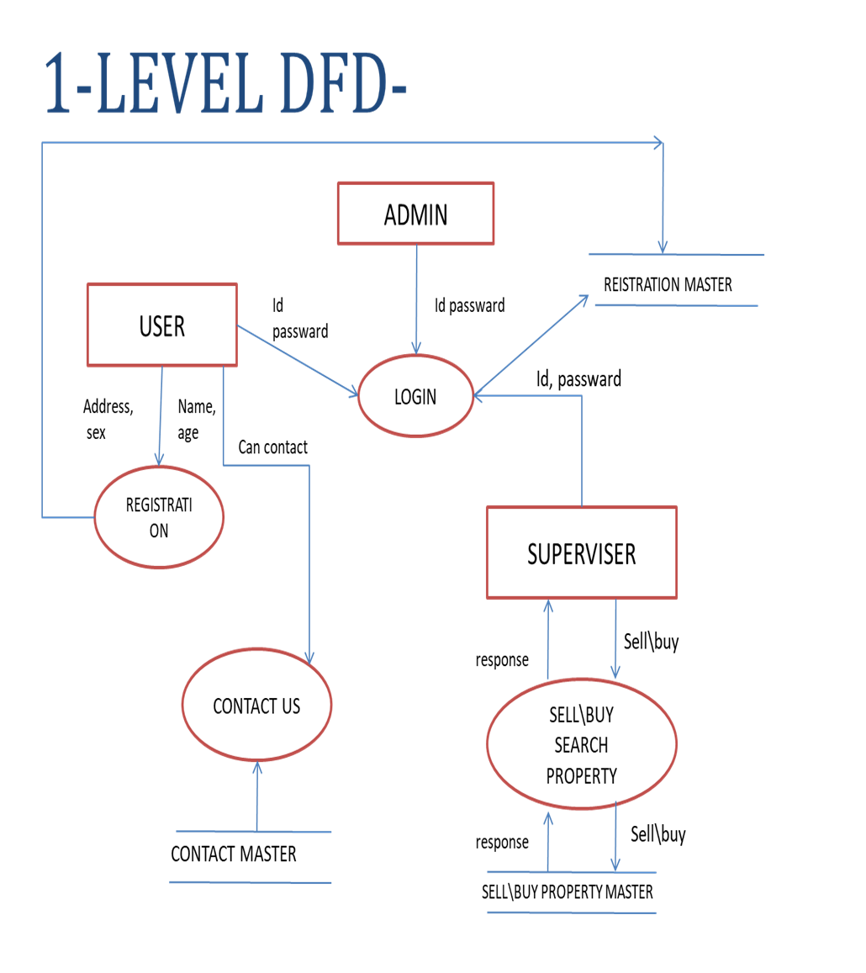

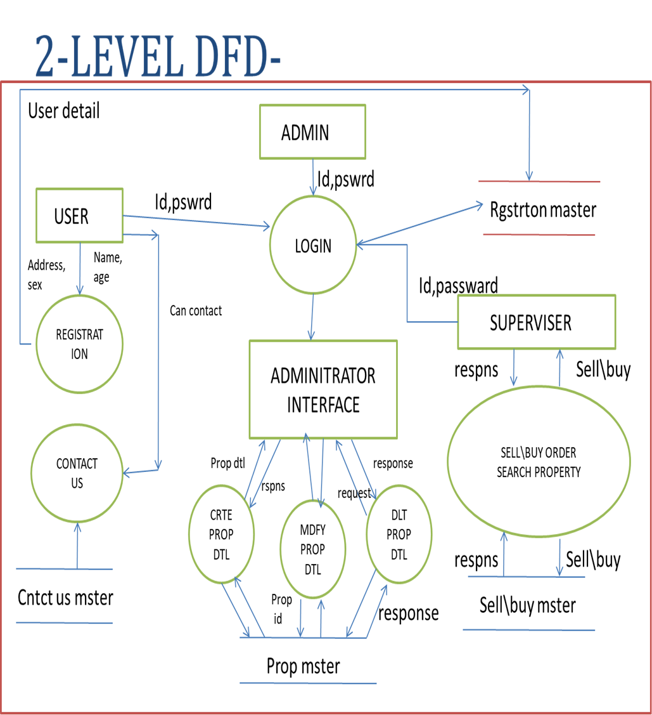

**E-R DIAGRAM:**

|  |  |  |
| --- | --- | --- |
| insert  Insert  Property  contact  Client |  |  |

**UNIFIED MODELING LANGUAGE (UML):**

**CASE DIAGRAM:**

* A case diagram is a graphical depiction of the interaction among the element of the system
* A case is a methodology used in system analysis is to identify, clarify and organize system

requirement.

* In this context, the term “system” refers to something being developed or operate, Such as a mail-order product sales and service web sites. System objectives can include planning overall requirement, validating a hardware design, testing and debugging a software product under development creating an online help reference, or performing a consumer service - oriented task.

**ABOUT THE CUSTOMER CASE DIAGRAM:**

* This is the customer case diagram. In this diagram customer firstly login into the application or sign up and then he can configure the user, manage user, update data base, create user and can add some new feature. It tells us how a process may relate with actor.
* To perform any action we must insert data into the application, so it can easy flow of control to manage the functionality of the application. It is very easy to understand the work of administrative. It pronounced like case diagram of the admin because of the diagrammatic form of the process control that means to know how a case sensitivity of diagram.

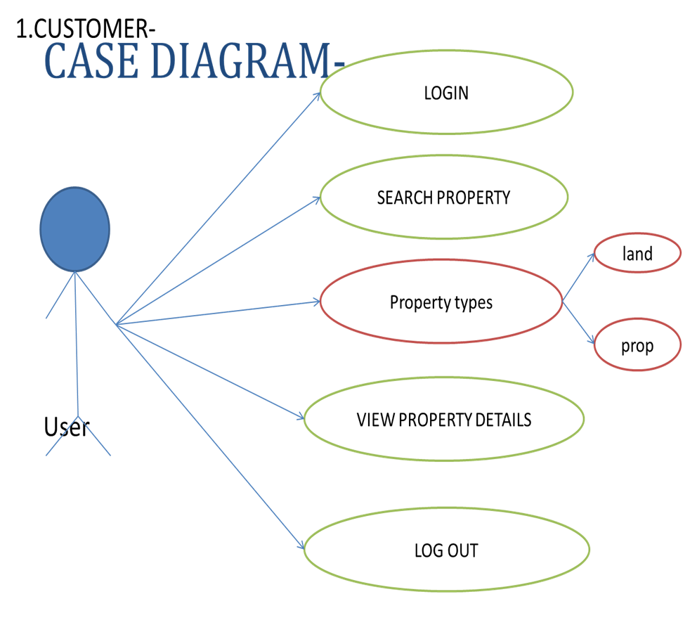

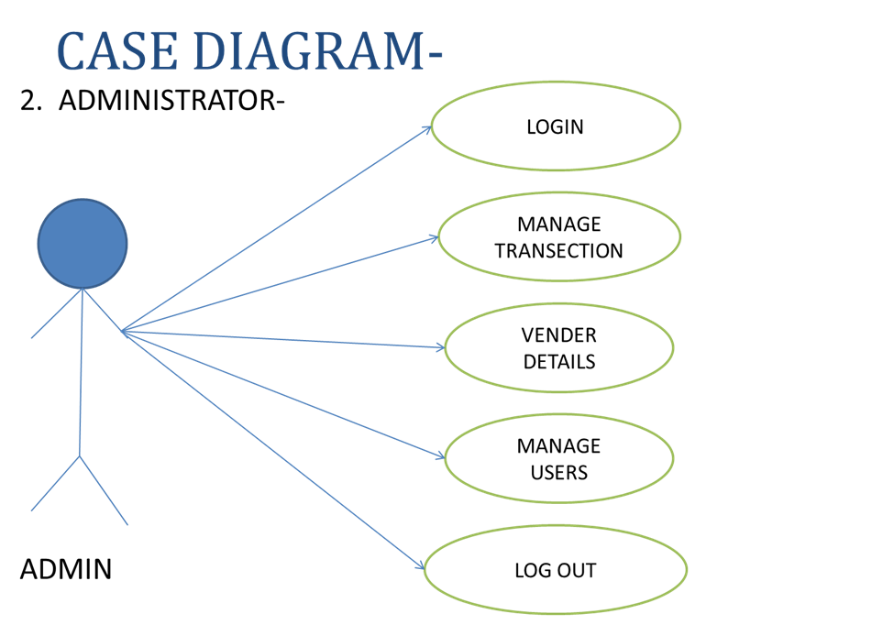

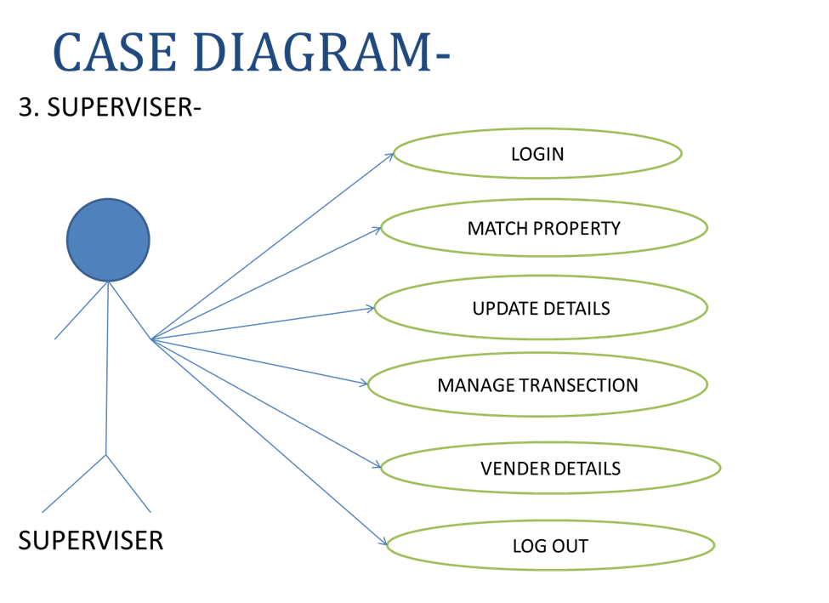

**Use Case Diagram**

A Use case diagram is a graphical depiction of the interaction among the element of the system. A use case is a methodology used in system analysis is to identify, clarify and organize system requirement. In this context, the term “system” refers to something being developed or operate, such as an online food ordering system and service. System objectives can include planning overall requirement, validating a hardware design, testing and debugging a software product under development creating an online help reference, or performing a customer service -oriented task.

